江门市区暴雨强度公式及计算图表

江门市水务局
江门市气象局
广东省气候中心
二零一五年十二月
说
1.本计算图表以新会国家气象观测站35年（1980～2014年）连续自记雨量记录为基础，利用国内先进的“降水数字化处理系统”得到高精度的原始数据，采用年最大值法进行编制。
2.以重现期2、3、5、10、20、30、50、100（年）相应的单一重现期暴雨强度公式制表。设计暴雨强度可按选定设计重现期直接查用表列数值（单一重现期暴雨强度公式见表一）。
3.若采用其它重现期，设计暴雨强度可用重现期区间参数公式计算：
式中：q—设计暴雨强度（升/秒·公顷）
t—降雨历时（分钟）
A—雨力
b、n—地方常数
（A、b、n按重现期区间参数公式计算，公式见表二）
4.考虑到绘制全国城市暴雨强度公式等值线图，列出包含重现期在内的暴雨强度总公式：
因总公式精度不及重现期区间参数公式，故建议推求其它重现期设计暴雨强度时使用区间参数公式。
明
应用重现期区间参数公式计算暴雨强度实例：求P=25年，t=50分钟的暴雨强度q。
从重现期区间参数公式II，得：
n=0.719 -0.078Lg(P - 4.527)
=0.61635（取0.616）
b=13.953 -4.138Lg(P - 6.185)
=8.67943（取8.679）
A=21.737 -2.945Lg(P - 6.737)
=18.02166（取18.022）
配得P=25年的暴雨强度计算公式如下：
可按上式计算1～200分钟中任何时段的暴雨强度。
当 t=50：
=244.982（升/秒/公顷）
5.公式误差
重现期2～20年的暴雨强度公式算得的平均绝对均方差为：0.025（mm/min），平均相对均方差为：1.97%。精度符合《室外排水设计规范》（GB50014—2006，2014年版）提出的要求。
表一 单一重现期暴雨强度公式

重现期 P（年） | 公 式
P＝2 | 4830.308 / (t + 17.044) ^{0.803}
P＝3 | 4359.535 / (t + 15.633) ^{0.760}
P＝5 | 3853.024 / (t + 13.926) ^{0.712}
P＝10 | 3377.408 / (t + 11.547) ^{0.661}
P＝20 | 3077.977 / (t + 9.235) ^{0.626}
P＝30 | 2957.904 / (t + 8.256) ^{0.609}
P＝50 | 2825.473 / (t + 7.160) ^{0.589}
P＝100 | 2661.312 / (t + 5.792) ^{0.564}

表二 重现期区间暴雨强度公式

P（年） | 区间 | 参数 | 公 式
1 — 10 | I | n | 0.827 -0.180Lg(P - 0.640)
1 — 10 | I | b | 18.799 -7.198Lg (P - 0.247)
1 — 10 | I | A | 29.900 -10.903Lg (P - 0.771)
10—100 | II | n | 0.719 -0.078Lg (P - 4.527)
10—100 | II | b | 13.953 -4.138Lg (P - 6.185)
10—100 | II | A | 21.737 -2.945Lg (P - 6.737)
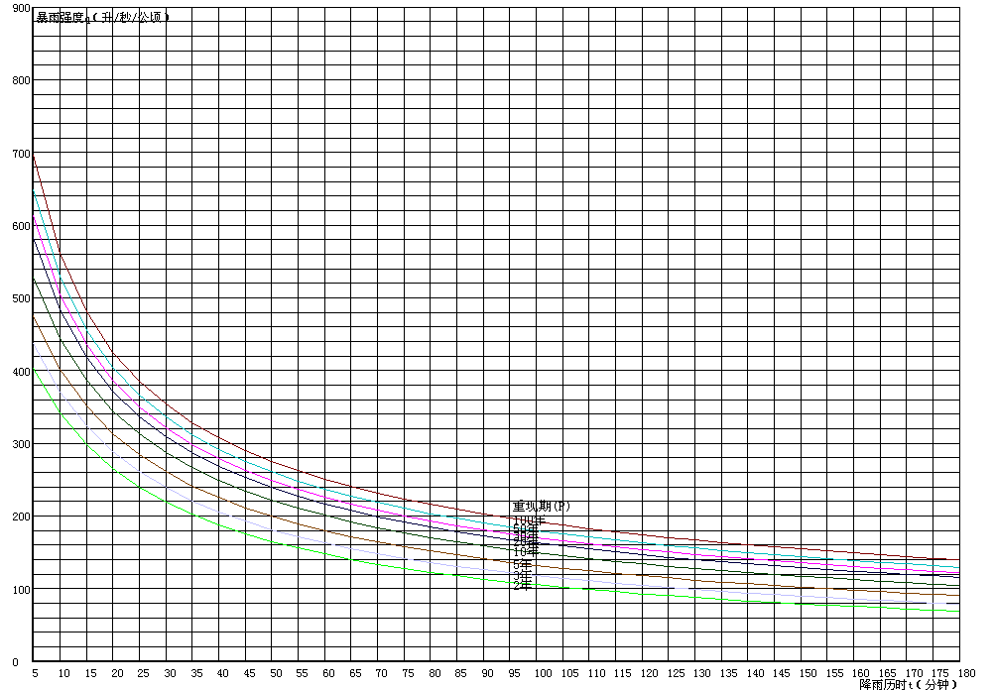
江门市区暴雨强度曲线
2015年编制

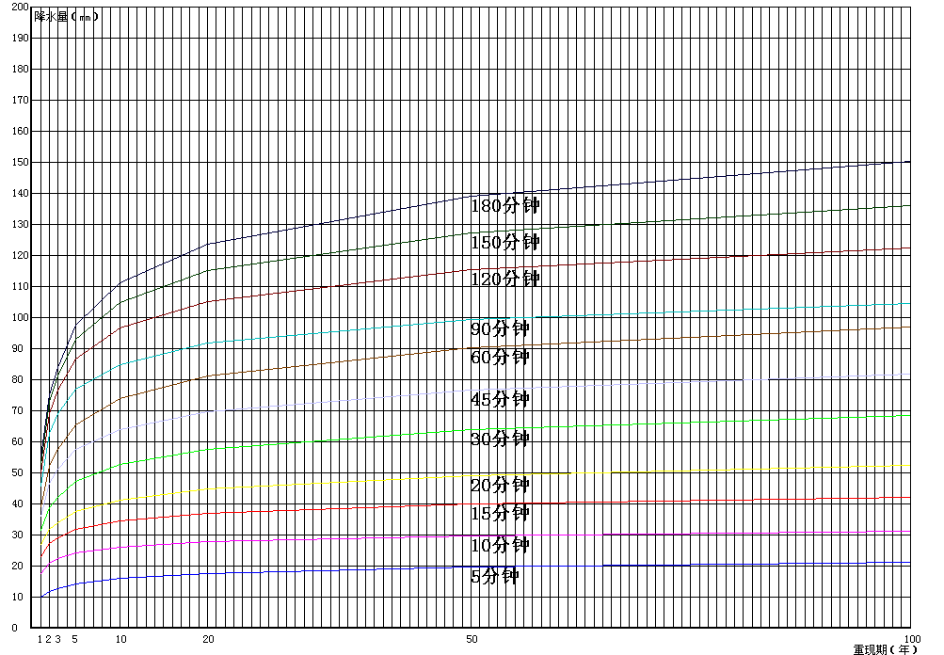
延长样本资料后的降水量与重现期曲线图
P=2(年) t：分钟；q：升/秒/公顷
t | q | t | q | t | q | t | q | t | q | t | q | t | q
1 | 473.303 | 27 | 231.171 | 53 | 159.273 | 79 | 123.609 | 105 | 101.977 | 131 | 87.327 | 157 | 76.688
2 | 453.241 | 28 | 227.041 | 54 | 157.470 | 80 | 122.585 | 106 | 101.311 | 132 | 86.857 | 158 | 76.336
3 | 434.992 | 29 | 223.073 | 55 | 155.713 | 81 | 121.580 | 107 | 100.655 | 133 | 86.392 | 159 | 75.987
4 | 418.314 | 30 | 219.257 | 56 | 153.998 | 82 | 120.594 | 108 | 100.008 | 134 | 85.932 | 160 | 75.642
5 | 403.007 | 31 | 215.585 | 57 | 152.326 | 83 | 119.625 | 109 | 99.370 | 135 | 85.478 | 161 | 75.301
6 | 388.903 | 32 | 212.048 | 58 | 150.694 | 84 | 118.673 | 110 | 98.741 | 136 | 85.029 | 162 | 74.963
7 | 375.860 | 33 | 208.639 | 59 | 149.101 | 85 | 117.738 | 111 | 98.122 | 137 | 84.586 | 163 | 74.629
8 | 363.761 | 34 | 205.350 | 60 | 147.545 | 86 | 116.820 | 112 | 97.511 | 138 | 84.147 | 164 | 74.297
9 | 352.502 | 35 | 202.176 | 61 | 146.025 | 87 | 115.918 | 113 | 96.908 | 139 | 83.714 | 165 | 73.970
10 | 341.997 | 36 | 199.109 | 62 | 144.539 | 88 | 115.031 | 114 | 96.314 | 140 | 83.286 | 166 | 73.645
11 | 332.169 | 37 | 196.146 | 63 | 143.088 | 89 | 114.159 | 115 | 95.728 | 141 | 82.862 | 167 | 73.323
12 | 322.954 | 38 | 193.279 | 64 | 141.668 | 90 | 113.302 | 116 | 95.150 | 142 | 82.444 | 168 | 73.005
13 | 314.293 | 39 | 190.505 | 65 | 140.280 | 91 | 112.459 | 117 | 94.579 | 143 | 82.030 | 169 | 72.690
14 | 306.138 | 40 | 187.818 | 66 | 138.922 | 92 | 111.630 | 118 | 94.016 | 144 | 81.620 | 170 | 72.378
15 | 298.442 | 41 | 185.216 | 67 | 137.593 | 93 | 110.815 | 119 | 93.461 | 145 | 81.216 | 171 | 72.068
16 | 291.168 | 42 | 182.692 | 68 | 136.292 | 94 | 110.013 | 120 | 92.913 | 146 | 80.815 | 172 | 71.762
17 | 284.280 | 43 | 180.245 | 69 | 135.019 | 95 | 109.223 | 121 | 92.372 | 147 | 80.420 | 173 | 71.459
18 | 277.747 | 44 | 177.870 | 70 | 133.772 | 96 | 108.447 | 122 | 91.838 | 148 | 80.028 | 174 | 71.158
19 | 271.543 | 45 | 175.565 | 71 | 132.550 | 97 | 107.683 | 123 | 91.311 | 149 | 79.641 | 175 | 70.860
20 | 265.641 | 46 | 173.325 | 72 | 131.354 | 98 | 106.930 | 124 | 90.791 | 150 | 79.258 | 176 | 70.566
21 | 260.019 | 47 | 171.148 | 73 | 130.181 | 99 | 106.190 | 125 | 90.277 | 151 | 78.879 | 177 | 70.273
22 | 254.658 | 48 | 169.032 | 74 | 129.032 | 100 | 105.461 | 126 | 89.770 | 152 | 78.504 | 178 | 69.984
23 | 249.538 | 49 | 166.974 | 75 | 127.905 | 101 | 104.743 | 127 | 89.270 | 153 | 78.133 | 179 | 69.697
24 | 244.644 | 50 | 164.971 | 76 | 126.800 | 102 | 104.036 | 128 | 88.775 | 154 | 77.766 | 180 | 69.413
25 | 239.961 | 51 | 163.021 | 77 | 125.716 | 103 | 103.339 | 129 | 88.287 | 155 | 77.403 | 181 | 69.131
26 | 235.474 | 52 | 161.123 | 78 | 124.653 | 104 | 102.653 | 130 | 87.804 | 156 | 77.043 | 182 | 68.852
P=3(年) t：分钟；q：升/秒/公顷
t | q | t | q | t | q | t | q | t | q | t | q | t | q
1 | 514.639 | 27 | 251.671 | 53 | 175.257 | 79 | 137.293 | 105 | 114.163 | 131 | 98.425 | 157 | 86.941
2 | 492.303 | 28 | 247.275 | 54 | 173.341 | 80 | 136.200 | 106 | 113.449 | 132 | 97.918 | 158 | 86.560
3 | 472.090 | 29 | 243.053 | 55 | 171.472 | 81 | 135.128 | 107 | 112.745 | 133 | 97.417 | 159 | 86.184
4 | 453.702 | 30 | 238.995 | 56 | 169.650 | 82 | 134.075 | 108 | 112.052 | 134 | 96.921 | 160 | 85.810
5 | 436.891 | 31 | 235.089 | 57 | 167.872 | 83 | 133.040 | 109 | 111.368 | 135 | 96.432 | 161 | 85.441
6 | 421.455 | 32 | 231.329 | 58 | 166.137 | 84 | 132.024 | 110 | 110.693 | 136 | 95.948 | 162 | 85.075
7 | 407.227 | 33 | 227.705 | 59 | 164.442 | 85 | 131.026 | 111 | 110.028 | 137 | 95.470 | 163 | 84.713
8 | 394.063 | 34 | 224.210 | 60 | 162.787 | 86 | 130.045 | 112 | 109.373 | 138 | 94.997 | 164 | 84.354
9 | 381.845 | 35 | 220.836 | 61 | 161.170 | 87 | 129.081 | 113 | 108.726 | 139 | 94.530 | 165 | 83.999
10 | 370.470 | 36 | 217.578 | 62 | 159.590 | 88 | 128.133 | 114 | 108.088 | 140 | 94.068 | 166 | 83.647
11 | 359.849 | 37 | 214.429 | 63 | 158.045 | 89 | 127.201 | 115 | 107.458 | 141 | 93.611 | 167 | 83.299
12 | 349.909 | 38 | 211.384 | 64 | 156.534 | 90 | 126.285 | 116 | 106.837 | 142 | 93.160 | 168 | 82.954
13 | 340.582 | 39 | 208.437 | 65 | 155.057 | 91 | 125.384 | 117 | 106.225 | 143 | 92.713 | 169 | 82.612
14 | 331.811 | 40 | 205.583 | 66 | 153.611 | 92 | 124.498 | 118 | 105.620 | 144 | 92.271 | 170 | 82.274
15 | 323.546 | 41 | 202.818 | 67 | 152.196 | 93 | 123.626 | 119 | 105.023 | 145 | 91.834 | 171 | 81.939
16 | 315.743 | 42 | 200.138 | 68 | 150.811 | 94 | 122.768 | 120 | 104.434 | 146 | 91.402 | 172 | 81.607
17 | 308.362 | 43 | 197.539 | 69 | 149.455 | 95 | 121.924 | 121 | 103.853 | 147 | 90.975 | 173 | 81.278
18 | 301.369 | 44 | 195.016 | 70 | 148.127 | 96 | 121.093 | 122 | 103.279 | 148 | 90.552 | 174 | 80.952
19 | 294.732 | 45 | 192.567 | 71 | 146.825 | 97 | 120.275 | 123 | 102.712 | 149 | 90.134 | 175 | 80.629
20 | 288.425 | 46 | 190.188 | 72 | 145.550 | 98 | 119.469 | 124 | 102.153 | 150 | 89.720 | 176 | 80.309
21 | 282.421 | 47 | 187.875 | 73 | 144.300 | 99 | 118.677 | 125 | 101.600 | 151 | 89.310 | 177 | 79.992
22 | 276.699 | 48 | 185.627 | 74 | 143.075 | 100 | 117.896 | 126 | 101.054 | 152 | 88.905 | 178 | 79.678
23 | 271.239 | 49 | 183.440 | 75 | 141.874 | 101 | 117.127 | 127 | 100.515 | 153 | 88.504 | 179 | 79.366
24 | 266.022 | 50 | 181.312 | 76 | 140.696 | 102 | 116.369 | 128 | 99.983 | 154 | 88.107 | 180 | 79.058
25 | 261.031 | 51 | 179.241 | 77 | 139.540 | 103 | 115.623 | 129 | 99.457 | 155 | 87.715 | 181 | 78.752
26 | 256.252 | 52 | 177.223 | 78 | 138.406 | 104 | 114.888 | 130 | 98.938 | 156 | 87.326 | 182 | 78.449
P=5(年) t：分钟；q：升/秒/公顷
t | q | t | q | t | q | t | q | t | q | t | q | t | q
1 | 562.282 | 27 | 274.194 | 53 | 193.187 | 79 | 152.928 | 105 | 128.293 | 131 | 111.446 | 157 | 99.093
2 | 536.910 | 28 | 269.522 | 54 | 191.158 | 80 | 151.767 | 106 | 127.531 | 132 | 110.902 | 158 | 98.682
3 | 514.128 | 29 | 265.036 | 55 | 189.179 | 81 | 150.627 | 107 | 126.779 | 133 | 110.364 | 159 | 98.275
4 | 493.539 | 30 | 260.726 | 56 | 187.249 | 82 | 149.508 | 108 | 126.038 | 134 | 109.832 | 160 | 97.873
5 | 474.827 | 31 | 256.580 | 57 | 185.365 | 83 | 148.408 | 109 | 125.307 | 135 | 109.307 | 161 | 97.474
6 | 457.735 | 32 | 252.590 | 58 | 183.527 | 84 | 147.327 | 110 | 124.586 | 136 | 108.787 | 162 | 97.079
7 | 442.052 | 33 | 248.746 | 59 | 181.731 | 85 | 146.265 | 111 | 123.875 | 137 | 108.273 | 163 | 96.688
8 | 427.601 | 34 | 245.039 | 60 | 179.977 | 86 | 145.221 | 112 | 123.174 | 138 | 107.765 | 164 | 96.301
9 | 414.236 | 35 | 241.462 | 61 | 178.264 | 87 | 144.195 | 113 | 122.482 | 139 | 107.263 | 165 | 95.918
10 | 401.834 | 36 | 238.009 | 62 | 176.589 | 88 | 143.187 | 114 | 121.800 | 140 | 106.767 | 166 | 95.538
11 | 390.288 | 37 | 234.672 | 63 | 174.951 | 89 | 142.195 | 115 | 121.127 | 141 | 106.276 | 167 | 95.161
12 | 379.509 | 38 | 231.445 | 64 | 173.350 | 90 | 141.219 | 116 | 120.462 | 142 | 105.790 | 168 | 94.789
13 | 369.419 | 39 | 228.323 | 65 | 171.783 | 91 | 140.260 | 117 | 119.806 | 143 | 105.309 | 169 | 94.419
14 | 359.951 | 40 | 225.300 | 66 | 170.250 | 92 | 139.316 | 118 | 119.159 | 144 | 104.834 | 170 | 94.054
15 | 351.046 | 41 | 222.372 | 67 | 168.750 | 93 | 138.387 | 119 | 118.520 | 145 | 104.364 | 171 | 93.691
16 | 342.653 | 42 | 219.533 | 68 | 167.281 | 94 | 137.473 | 120 | 117.889 | 146 | 103.899 | 172 | 93.332
17 | 334.727 | 43 | 216.781 | 69 | 165.842 | 95 | 136.573 | 121 | 117.266 | 147 | 103.439 | 173 | 92.976
18 | 327.228 | 44 | 214.109 | 70 | 164.432 | 96 | 135.687 | 122 | 116.651 | 148 | 102.984 | 174 | 92.624
19 | 320.121 | 45 | 211.516 | 71 | 163.051 | 97 | 134.815 | 123 | 116.044 | 149 | 102.533 | 175 | 92.275
20 | 313.374 | 46 | 208.997 | 72 | 161.698 | 98 | 133.956 | 124 | 115.445 | 150 | 102.087 | 176 | 91.928
21 | 306.959 | 47 | 206.549 | 73 | 160.371 | 99 | 133.111 | 125 | 114.852 | 151 | 101.646 | 177 | 91.585
22 | 300.850 | 48 | 204.168 | 74 | 159.071 | 100 | 132.278 | 126 | 114.267 | 152 | 101.210 | 178 | 91.245
23 | 295.027 | 49 | 201.853 | 75 | 157.795 | 101 | 131.457 | 127 | 113.689 | 153 | 100.778 | 179 | 90.908
24 | 289.467 | 50 | 199.599 | 76 | 156.544 | 102 | 130.649 | 128 | 113.118 | 154 | 100.350 | 180 | 90.574
25 | 284.152 | 51 | 197.406 | 77 | 155.316 | 103 | 129.852 | 129 | 112.554 | 155 | 99.927 | 181 | 90.243
26 | 279.066 | 52 | 195.269 | 78 | 154.111 | 104 | 129.067 | 130 | 111.997 | 156 | 99.508 | 182 | 89.915
P=10(年) t：分钟；q：升/秒/公顷
t | q | t | q | t | q | t | q | t | q | t | q | t | q
1 | 634.525 | 27 | 302.165 | 53 | 214.909 | 79 | 171.826 | 105 | 145.421 | 131 | 127.297 | 157 | 113.952
2 | 603.164 | 28 | 297.092 | 54 | 212.737 | 80 | 170.583 | 106 | 144.602 | 132 | 126.710 | 158 | 113.507
3 | 575.427 | 29 | 292.229 | 55 | 210.618 | 81 | 169.363 | 107 | 143.794 | 133 | 126.130 | 159 | 113.067
4 | 550.687 | 30 | 287.560 | 56 | 208.552 | 82 | 168.164 | 108 | 142.998 | 134 | 125.556 | 160 | 112.631
5 | 528.458 | 31 | 283.075 | 57 | 206.536 | 83 | 166.986 | 109 | 142.213 | 135 | 124.989 | 161 | 112.199
6 | 508.353 | 32 | 278.761 | 58 | 204.568 | 84 | 165.829 | 110 | 141.438 | 136 | 124.429 | 162 | 111.771
7 | 490.066 | 33 | 274.609 | 59 | 202.647 | 85 | 164.692 | 111 | 140.675 | 137 | 123.874 | 163 | 111.347
8 | 473.347 | 34 | 270.609 | 60 | 200.770 | 86 | 163.574 | 112 | 139.921 | 138 | 123.326 | 164 | 110.928
9 | 457.991 | 35 | 266.752 | 61 | 198.936 | 87 | 162.475 | 113 | 139.177 | 139 | 122.784 | 165 | 110.512
10 | 443.828 | 36 | 263.030 | 62 | 197.144 | 88 | 161.394 | 114 | 138.443 | 140 | 122.248 | 166 | 110.100
11 | 430.717 | 37 | 259.436 | 63 | 195.392 | 89 | 160.331 | 115 | 137.719 | 141 | 121.718 | 167 | 109.692
12 | 418.537 | 38 | 255.963 | 64 | 193.679 | 90 | 159.286 | 116 | 137.005 | 142 | 121.193 | 168 | 109.288
13 | 407.188 | 39 | 252.604 | 65 | 192.003 | 91 | 158.257 | 117 | 136.299 | 143 | 120.674 | 169 | 108.887
14 | 396.581 | 40 | 249.354 | 66 | 190.362 | 92 | 157.245 | 118 | 135.603 | 144 | 120.161 | 170 | 108.491
15 | 386.642 | 41 | 246.208 | 67 | 188.757 | 93 | 156.249 | 119 | 134.915 | 145 | 119.653 | 171 | 108.097
16 | 377.307 | 42 | 243.159 | 68 | 187.185 | 94 | 155.269 | 120 | 134.237 | 146 | 119.150 | 172 | 107.708
17 | 368.517 | 43 | 240.203 | 69 | 185.646 | 95 | 154.305 | 121 | 133.566 | 147 | 118.653 | 173 | 107.322
18 | 360.225 | 44 | 237.336 | 70 | 184.138 | 96 | 153.355 | 122 | 132.904 | 148 | 118.161 | 174 | 106.939
19 | 352.387 | 45 | 234.553 | 71 | 182.660 | 97 | 152.419 | 123 | 132.251 | 149 | 117.674 | 175 | 106.560
20 | 344.963 | 46 | 231.851 | 72 | 181.212 | 98 | 151.498 | 124 | 131.605 | 150 | 117.192 | 176 | 106.184
21 | 337.920 | 47 | 229.226 | 73 | 179.793 | 99 | 150.591 | 125 | 130.967 | 151 | 116.715 | 177 | 105.811
22 | 331.228 | 48 | 226.674 | 74 | 178.401 | 100 | 149.697 | 126 | 130.337 | 152 | 116.243 | 178 | 105.442
23 | 324.859 | 49 | 224.192 | 75 | 177.035 | 101 | 148.817 | 127 | 129.714 | 153 | 115.775 | 179 | 105.076
24 | 318.789 | 50 | 221.778 | 76 | 175.696 | 102 | 147.949 | 128 | 129.099 | 154 | 115.313 | 180 | 104.713
25 | 312.996 | 51 | 219.427 | 77 | 174.382 | 103 | 147.094 | 129 | 128.491 | 155 | 114.854 | 181 | 104.353
26 | 307.460 | 52 | 217.139 | 78 | 173.092 | 104 | 146.251 | 130 | 127.890 | 156 | 114.401 | 182 | 103.996
P=20(年) t：分钟；q：升/秒/公顷
t | q | t | q | t | q | t | q | t | q | t | q | t | q
1 | 717.712 | 27 | 325.275 | 53 | 231.846 | 79 | 186.335 | 105 | 158.520 | 131 | 139.423 | 157 | 125.341
2 | 677.028 | 28 | 319.779 | 54 | 229.544 | 80 | 185.025 | 106 | 157.657 | 132 | 138.804 | 158 | 124.871
3 | 641.838 | 29 | 314.517 | 55 | 227.300 | 81 | 183.739 | 107 | 156.807 | 133 | 138.192 | 159 | 124.406
4 | 611.035 | 30 | 309.475 | 56 | 225.113 | 82 | 182.475 | 108 | 155.968 | 134 | 137.587 | 160 | 123.945
5 | 583.799 | 31 | 304.637 | 57 | 222.979 | 83 | 181.234 | 109 | 155.141 | 135 | 136.989 | 161 | 123.489
6 | 559.508 | 32 | 299.991 | 58 | 220.897 | 84 | 180.015 | 110 | 154.325 | 136 | 136.398 | 162 | 123.037
7 | 537.678 | 33 | 295.525 | 59 | 218.865 | 85 | 178.817 | 111 | 153.520 | 137 | 135.814 | 163 | 122.590
8 | 517.931 | 34 | 291.227 | 60 | 216.881 | 86 | 177.639 | 112 | 152.726 | 138 | 135.235 | 164 | 122.146
9 | 499.964 | 35 | 287.089 | 61 | 214.943 | 87 | 176.481 | 113 | 151.943 | 139 | 134.664 | 165 | 121.707
10 | 483.530 | 36 | 283.099 | 62 | 213.049 | 88 | 175.343 | 114 | 151.170 | 140 | 134.098 | 166 | 121.271
11 | 468.430 | 37 | 279.250 | 63 | 211.198 | 89 | 174.223 | 115 | 150.407 | 141 | 133.539 | 167 | 120.840
12 | 454.497 | 38 | 275.535 | 64 | 209.388 | 90 | 173.122 | 116 | 149.654 | 142 | 132.985 | 168 | 120.413
13 | 441.591 | 39 | 271.945 | 65 | 207.618 | 91 | 172.039 | 117 | 148.911 | 143 | 132.438 | 169 | 119.990
14 | 429.596 | 40 | 268.474 | 66 | 205.886 | 92 | 170.973 | 118 | 148.177 | 144 | 131.896 | 170 | 119.570
15 | 418.412 | 41 | 265.116 | 67 | 204.191 | 93 | 169.925 | 119 | 147.453 | 145 | 131.360 | 171 | 119.154
16 | 407.954 | 42 | 261.864 | 68 | 202.532 | 94 | 168.892 | 120 | 146.738 | 146 | 130.830 | 172 | 118.742
17 | 398.149 | 43 | 258.715 | 69 | 200.908 | 95 | 167.876 | 121 | 146.031 | 147 | 130.305 | 173 | 118.334
18 | 388.934 | 44 | 255.662 | 70 | 199.317 | 96 | 166.876 | 122 | 145.334 | 148 | 129.785 | 174 | 117.929
19 | 380.253 | 45 | 252.701 | 71 | 197.758 | 97 | 165.891 | 123 | 144.645 | 149 | 129.271 | 175 | 117.528
20 | 372.057 | 46 | 249.827 | 72 | 196.230 | 98 | 164.921 | 124 | 143.964 | 150 | 128.762 | 176 | 117.131
21 | 364.306 | 47 | 247.037 | 73 | 194.733 | 99 | 163.965 | 125 | 143.292 | 151 | 128.259 | 177 | 116.737
22 | 356.960 | 48 | 244.326 | 74 | 193.265 | 100 | 163.024 | 126 | 142.628 | 152 | 127.760 | 178 | 116.346
23 | 349.987 | 49 | 241.691 | 75 | 191.826 | 101 | 162.096 | 127 | 141.971 | 153 | 127.267 | 179 | 115.959
24 | 343.357 | 50 | 239.128 | 76 | 190.414 | 102 | 161.183 | 128 | 141.323 | 154 | 126.778 | 180 | 115.575
25 | 337.044 | 51 | 236.636 | 77 | 189.029 | 103 | 160.282 | 129 | 140.682 | 155 | 126.294 | 181 | 115.194
26 | 331.024 | 52 | 234.209 | 78 | 187.669 | 104 | 159.395 | 130 | 140.049 | 156 | 125.815 | 182 | 114.816
P=30(年) t：分钟；q：升/秒/公顷
t | q | t | q | t | q | t | q | t | q | t | q | t | q
1 | 762.838 | 27 | 337.846 | 53 | 241.330 | 79 | 194.554 | 105 | 165.982 | 131 | 146.353 | 157 | 131.864
2 | 716.636 | 28 | 332.140 | 54 | 238.961 | 80 | 193.208 | 106 | 165.096 | 132 | 145.717 | 158 | 131.380
3 | 677.160 | 29 | 326.682 | 55 | 236.654 | 81 | 191.887 | 107 | 164.222 | 133 | 145.087 | 159 | 130.901
4 | 642.954 | 30 | 321.455 | 56 | 234.404 | 82 | 190.590 | 108 | 163.360 | 134 | 144.465 | 160 | 130.427
5 | 612.964 | 31 | 316.443 | 57 | 232.210 | 83 | 189.315 | 109 | 162.510 | 135 | 143.850 | 161 | 129.957
6 | 586.407 | 32 | 311.632 | 58 | 230.069 | 84 | 188.063 | 110 | 161.672 | 136 | 143.242 | 162 | 129.492
7 | 562.689 | 33 | 307.010 | 59 | 227.980 | 85 | 186.832 | 111 | 160.845 | 137 | 142.641 | 163 | 129.031
8 | 541.348 | 34 | 302.565 | 60 | 225.940 | 86 | 185.622 | 112 | 160.029 | 138 | 142.046 | 164 | 128.574
9 | 522.020 | 35 | 298.285 | 61 | 223.947 | 87 | 184.433 | 113 | 159.224 | 139 | 141.458 | 165 | 128.122
10 | 504.415 | 36 | 294.162 | 62 | 222.000 | 88 | 183.264 | 114 | 158.430 | 140 | 140.876 | 166 | 127.673
11 | 488.296 | 37 | 290.187 | 63 | 220.098 | 89 | 182.114 | 115 | 157.646 | 141 | 140.301 | 167 | 127.229
12 | 473.470 | 38 | 286.350 | 64 | 218.238 | 90 | 180.983 | 116 | 156.872 | 142 | 139.731 | 168 | 126.789
13 | 459.778 | 39 | 282.644 | 65 | 216.419 | 91 | 179.870 | 117 | 156.108 | 143 | 139.168 | 169 | 126.353
14 | 447.084 | 40 | 279.062 | 66 | 214.639 | 92 | 178.775 | 118 | 155.354 | 144 | 138.611 | 170 | 125.921
15 | 435.276 | 41 | 275.598 | 67 | 212.897 | 93 | 177.698 | 119 | 154.609 | 145 | 138.059 | 171 | 125.493
16 | 424.257 | 42 | 272.245 | 68 | 211.193 | 94 | 176.638 | 120 | 153.874 | 146 | 137.513 | 172 | 125.068
17 | 413.946 | 43 | 268.998 | 69 | 209.524 | 95 | 175.594 | 121 | 153.148 | 147 | 136.973 | 173 | 124.648
18 | 404.272 | 44 | 265.852 | 70 | 207.889 | 96 | 174.566 | 122 | 152.431 | 148 | 136.439 | 174 | 124.231
19 | 395.173 | 45 | 262.800 | 71 | 206.288 | 97 | 173.554 | 123 | 151.722 | 149 | 135.910 | 175 | 123.817
20 | 386.596 | 46 | 259.840 | 72 | 204.719 | 98 | 172.558 | 124 | 151.023 | 150 | 135.386 | 176 | 123.408
21 | 378.494 | 47 | 256.966 | 73 | 203.181 | 99 | 171.576 | 125 | 150.331 | 151 | 134.868 | 177 | 123.002
22 | 370.826 | 48 | 254.174 | 74 | 201.673 | 100 | 170.609 | 126 | 149.649 | 152 | 134.354 | 178 | 122.599
23 | 363.555 | 49 | 251.461 | 75 | 200.194 | 101 | 169.657 | 127 | 148.974 | 153 | 133.846 | 179 | 122.200
24 | 356.648 | 50 | 248.824 | 76 | 198.744 | 102 | 168.718 | 128 | 148.307 | 154 | 133.343 | 180 | 121.804
25 | 350.078 | 51 | 246.258 | 77 | 197.321 | 103 | 167.793 | 129 | 147.648 | 155 | 132.845 | 181 | 121.412
26 | 343.819 | 52 | 243.761 | 78 | 195.924 | 104 | 166.881 | 130 | 146.997 | 156 | 132.352 | 182 | 121.023
P=50(年) t：分钟；q：升/秒/公顷
t | q | t | q | t | q | t | q | t | q | t | q | t | q
1 | 820.551 | 27 | 353.061 | 53 | 252.976 | 79 | 204.737 | 105 | 175.282 | 131 | 155.027 | 157 | 140.055
2 | 766.540 | 28 | 347.111 | 54 | 250.531 | 80 | 203.350 | 106 | 174.368 | 132 | 154.369 | 158 | 139.555
3 | 721.159 | 29 | 341.424 | 55 | 248.149 | 81 | 201.988 | 107 | 173.466 | 133 | 153.720 | 159 | 139.060
4 | 682.365 | 30 | 335.982 | 56 | 245.828 | 82 | 200.651 | 108 | 172.578 | 134 | 153.077 | 160 | 138.569
5 | 648.732 | 31 | 330.768 | 57 | 243.564 | 83 | 199.337 | 109 | 171.701 | 135 | 152.442 | 161 | 138.083
6 | 619.226 | 32 | 325.767 | 58 | 241.355 | 84 | 198.046 | 110 | 170.836 | 136 | 151.814 | 162 | 137.602
7 | 593.082 | 33 | 320.964 | 59 | 239.200 | 85 | 196.778 | 111 | 169.983 | 137 | 151.193 | 163 | 137.125
8 | 569.717 | 34 | 316.348 | 60 | 237.095 | 86 | 195.531 | 112 | 169.142 | 138 | 150.579 | 164 | 136.652
9 | 548.680 | 35 | 311.907 | 61 | 235.040 | 87 | 194.305 | 113 | 168.311 | 139 | 149.971 | 165 | 136.184
10 | 529.615 | 36 | 307.630 | 62 | 233.033 | 88 | 193.100 | 114 | 167.491 | 140 | 149.370 | 166 | 135.721
11 | 512.238 | 37 | 303.507 | 63 | 231.070 | 89 | 191.914 | 115 | 166.682 | 141 | 148.775 | 167 | 135.261
12 | 496.318 | 38 | 299.531 | 64 | 229.152 | 90 | 190.748 | 116 | 165.884 | 142 | 148.187 | 168 | 134.806
13 | 481.666 | 39 | 295.691 | 65 | 227.276 | 91 | 189.601 | 117 | 165.096 | 143 | 147.605 | 169 | 134.354
14 | 468.126 | 40 | 291.982 | 66 | 225.442 | 92 | 188.473 | 118 | 164.318 | 144 | 147.029 | 170 | 133.907
15 | 455.565 | 41 | 288.396 | 67 | 223.646 | 93 | 187.362 | 119 | 163.549 | 145 | 146.459 | 171 | 133.464
16 | 443.874 | 42 | 284.926 | 68 | 221.889 | 94 | 186.269 | 120 | 162.790 | 146 | 145.895 | 172 | 133.025
17 | 432.959 | 43 | 281.566 | 69 | 220.168 | 95 | 185.193 | 121 | 162.041 | 147 | 145.337 | 173 | 132.589
18 | 422.739 | 44 | 278.311 | 70 | 218.483 | 96 | 184.134 | 122 | 161.301 | 148 | 144.784 | 174 | 132.158
19 | 413.145 | 45 | 275.156 | 71 | 216.832 | 97 | 183.090 | 123 | 160.570 | 149 | 144.238 | 175 | 131.730
20 | 404.116 | 46 | 272.096 | 72 | 215.214 | 98 | 182.063 | 124 | 159.848 | 150 | 143.696 | 176 | 131.306
21 | 395.601 | 47 | 269.125 | 73 | 213.629 | 99 | 181.051 | 125 | 159.134 | 151 | 143.161 | 177 | 130.885
22 | 387.553 | 48 | 266.241 | 74 | 212.075 | 100 | 180.054 | 126 | 158.429 | 152 | 142.630 | 178 | 130.469
23 | 379.932 | 49 | 263.438 | 75 | 210.550 | 101 | 179.071 | 127 | 157.732 | 153 | 142.105 | 179 | 130.055
24 | 372.702 | 50 | 260.714 | 76 | 209.055 | 102 | 178.103 | 128 | 157.044 | 154 | 141.585 | 180 | 129.646
25 | 365.832 | 51 | 258.064 | 77 | 207.589 | 103 | 177.149 | 129 | 156.364 | 155 | 141.070 | 181 | 129.239
26 | 359.293 | 52 | 255.486 | 78 | 206.150 | 104 | 176.209 | 130 | 155.691 | 156 | 140.560 | 182 | 128.836
P=100(年) t：分钟；q：升/秒/公顷
t | q | t | q | t | q | t | q | t | q | t | q | t | q
1 | 903.336 | 27 | 371.709 | 53 | 267.424 | 79 | 217.522 | 105 | 187.065 | 131 | 166.095 | 157 | 150.569
2 | 835.999 | 28 | 365.464 | 54 | 264.892 | 80 | 216.089 | 106 | 186.120 | 132 | 165.414 | 158 | 150.050
3 | 780.963 | 29 | 359.502 | 55 | 262.426 | 81 | 214.681 | 107 | 185.187 | 133 | 164.741 | 159 | 149.535
4 | 734.927 | 30 | 353.802 | 56 | 260.022 | 82 | 213.298 | 108 | 184.268 | 134 | 164.076 | 160 | 149.026
5 | 695.707 | 31 | 348.346 | 57 | 257.678 | 83 | 211.940 | 109 | 183.360 | 135 | 163.417 | 161 | 148.521
6 | 661.790 | 32 | 343.117 | 58 | 255.392 | 84 | 210.606 | 110 | 182.466 | 136 | 162.766 | 162 | 148.022
7 | 632.095 | 33 | 338.100 | 59 | 253.162 | 85 | 209.294 | 111 | 181.583 | 137 | 162.122 | 163 | 147.526
8 | 605.823 | 34 | 333.281 | 60 | 250.984 | 86 | 208.005 | 112 | 180.712 | 138 | 161.485 | 164 | 147.036
9 | 582.372 | 35 | 328.648 | 61 | 248.858 | 87 | 206.738 | 113 | 179.852 | 139 | 160.855 | 165 | 146.549
10 | 561.277 | 36 | 324.190 | 62 | 246.781 | 88 | 205.492 | 114 | 179.004 | 140 | 160.232 | 166 | 146.068
11 | 542.173 | 37 | 319.895 | 63 | 244.751 | 89 | 204.266 | 115 | 178.167 | 141 | 159.616 | 167 | 145.590
12 | 524.770 | 38 | 315.754 | 64 | 242.767 | 90 | 203.061 | 116 | 177.340 | 142 | 159.006 | 168 | 145.117
13 | 508.833 | 39 | 311.759 | 65 | 240.827 | 91 | 201.875 | 117 | 176.524 | 143 | 158.402 | 169 | 144.648
14 | 494.169 | 40 | 307.901 | 66 | 238.929 | 92 | 200.708 | 118 | 175.718 | 144 | 157.805 | 170 | 144.184
15 | 480.621 | 41 | 304.172 | 67 | 237.072 | 93 | 199.560 | 119 | 174.923 | 145 | 157.214 | 171 | 143.723
16 | 468.054 | 42 | 300.566 | 68 | 235.255 | 94 | 198.429 | 120 | 174.137 | 146 | 156.629 | 172 | 143.267
17 | 456.359 | 43 | 297.076 | 69 | 233.476 | 95 | 197.317 | 121 | 173.361 | 147 | 156.050 | 173 | 142.814
18 | 445.440 | 44 | 293.696 | 70 | 231.733 | 96 | 196.221 | 122 | 172.595 | 148 | 155.477 | 174 | 142.366
19 | 435.215 | 45 | 290.420 | 71 | 230.026 | 97 | 195.142 | 123 | 171.838 | 149 | 154.909 | 175 | 141.921
20 | 425.616 | 46 | 287.244 | 72 | 228.354 | 98 | 194.079 | 124 | 171.090 | 150 | 154.348 | 176 | 141.480
21 | 416.582 | 47 | 284.163 | 73 | 226.715 | 99 | 193.033 | 125 | 170.351 | 151 | 153.792 | 177 | 141.043
22 | 408.061 | 48 | 281.171 | 74 | 225.108 | 100 | 192.001 | 126 | 169.621 | 152 | 153.241 | 178 | 140.610
23 | 400.006 | 49 | 278.265 | 75 | 223.532 | 101 | 190.985 | 127 | 168.899 | 153 | 152.696 | 179 | 140.180
24 | 392.377 | 50 | 275.441 | 76 | 221.987 | 102 | 189.984 | 128 | 168.186 | 154 | 152.157 | 180 | 139.754
25 | 385.138 | 51 | 272.695 | 77 | 220.470 | 103 | 188.997 | 129 | 167.481 | 155 | 151.622 | 181 | 139.332
26 | 378.258 | 52 | 270.024 | 78 | 218.983 | 104 | 188.024 | 130 | 166.784 | 156 | 151.093 | 182 | 138.913

